The Time Is Now to Abolish Abortion
By Joe Goodson, President, Concerned Christian Citizens

Without dispute, America’s greatest national evil is the murder of our own pre-born children. Our modern version of child sacrifice has claimed the lives of some 60,000,000 since 1973’s Roe v. Wade Supreme Court decision imposed upon us the destruction of our most innocent and most vulnerable fellow human beings. This horrific number does not include the untold millions whose lives have been snuffed out by abortifacient drugs, available over the counter at any drug store in town.

When will the Lord say, “Enough is enough?” If the blood of the first murder victim, Abel, cried out to God from the ground and brought a curse (Genesis 4:10-11), how much more must the blood of all the millions of slaughtered innocents cry out to Him from the land that, of all nations on the earth, has known better since its inception?

At the Republican State Convention in May, 88% of our delegates embraced the effort to abolish abortion in our state, making it one of this term’s Legislative Priorities. Last Wednesday, January 11th, history was made in Texas by the filing of HB948, the “Abolition of Abortion in Texas Act”. Sponsored by Rep. Tony Tinderholt of Arlington, this bill is long overdue and deserves our full support.

It is time we draw a line in the sand and say, as God would surely have us say, “Enough is enough!” It is time we rise up and take action in the mercy and justice of the Lord, undiluted and uncompromising, and declare as our final answer,
“Abolish abortion now!” No more regulating murder. No more patience with injustice. No more good-intentioned failure on our part, myself included for 30 years now, to press the true standard of justice for the unborn when it comes to our legislative efforts. No more bowing to a law (Roe v. Wade) that was no law from the beginning, but unjust to the core and worthy only of utter repudiation.

Lex iniqua lex non est: An unjust law is no law at all. In his famous letter from Birmingham Jail, Martin Luther King, Jr. echoes this truth: "One has not only a legal but a moral responsibility to obey just laws. Conversely, one has a moral responsibility to disobey unjust laws." Roe v. Wade has crushed its victims and imposed its tyranny upon our land and upon our state long enough.

“Establish justice in the gate!” says Amos 5:15 with an exclamation mark. With that same conviction we simply must abolish abortion now, by supporting the bold and clear bill that does just that: HB948. Call your state representative today and urge him or her to co-sponsor this no-nonsense, principle-over-pragmatism bill.

It is time we repent of allowing the sin of abortion among us. Abolition may be too difficult for us, but nothing will be impossible with God. I believe He is waiting on us, and nothing is too difficult for Him. Let’s start in Texas in 2017!
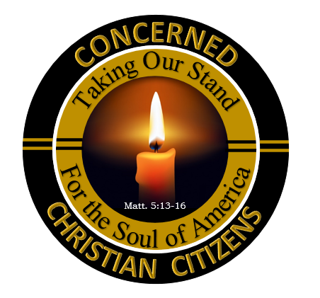

CONCERNED CHRISTIAN CITIZENS:
OUR STAND ON ABORTION

1. THE ABOLITION OF ABORTION, being the standard of justice for pre-born human beings, is to be pressed immediately and urgently, with sole reliance upon God to accomplish it (Genesis 1:26-28 / Exodus 20:13 / Ps. 89:14 / Amos 5:15).

2. THE GOSPEL OF JESUS CHRIST is the remedy for abortion, since He alone can change a heart
(Rom. 2:4 / 1 Cor. 6:9-11 / 2 Cor. 5:17 / 1 Pet. 3:18).

3. THE CHURCH OF JESUS CHRIST is the body of people God calls to seek the end of this holocaust
(Matt. 5:13-16 / Job 29:7-17 / Jeremiah 22:16 / Ezekiel 22:30).

4. THE LIKE-MINDED must stand together, without compromising these principles, in the effort to end abortion
(Acts 4:32 / Phil. 2:1-3; 4:1-9 / Eph. 4:11-13).

5. THE URGENCY OF GOD’S HEART on this matter must be demonstrated on the “frontlines” of the battle
(Daniel 11:32 / 1 Chronicles 12:32 / Matthew 6:10; 22:36-40 / Ephesians 5:11 / 1 Timothy 4:15).

www.concernedchristiancitizens.org / Facebook @ Concerned Christian Citizens

